ID TECH
UniMag II Android SDK
User Manual

80110513-001-K
2/11/2014

Revision History
Revision | Description | Date
50 | Initial release for SDK v2.0 | 10/07/2011
51 | Revised for SDK v2.2 | 10/25/2011
A | Initial release | 11/16/2011
B | Revised for SDK v2.4 and above | 12/28/2011
B1 | Updated for SDK v2.6 | 03/26/2012
B2 | Included table of enum definition | 03/28/2012
B3 | Included definition of new callback function | 03/28/2012
B4 | Added info about IDT_AutoConfig.jar | 04/10/2012
C | Rev. C release | 04/23/2012
D | Revised for SDK v2.8  Added clear buffer command and setFirmwareEncryptedBINFile API  No need of importing IDT_AutoConfig.jar  (Merged into IDTuniMagSDKAndroid.jar) | 07/17/2012
E | Revised for SDK v2.10  Added a list of messages from SDK | 8/30/2012
F | Revised for SDK v2.12  connectWithProfile API  new message, onReceiveMsgAutoConfigCompleted  New constructor added | 10/11/2012
G | new message, onReceiveAutoConfigProgress added | 12/13/2012
H | Revised for SDK v3.6  new message, onReceiveMsgProcessingCardData added | 3/4/2013
J | Revised for SDK v3.10  Description of getUserGrant method changed | 9/27/2013
K | Revised for SDK v4.2  New failure message added | 2/11/2014
UniMag II Android SDK User Manual
Before using the ID TECH UniMag II Android SDK, please have the following programs installed:
- Android SDK
- Eclipse
- ADT Plugin for Eclipse
Please see http://developer.android.com/sdk/index.html for download links and instructions. The below screenshots might not reflect the latest SDK version, please check with ID TECH for the latest SDK.
To use the UniMag Android SDK
- First, create an Android project. Please see http://developer.android.com/resources/tutorials/hello-world.html for sample instructions.
- Import the UniMag SDK package into the Android project.
- On the Package Explorer panel, right-click on the project and select “Properties”.
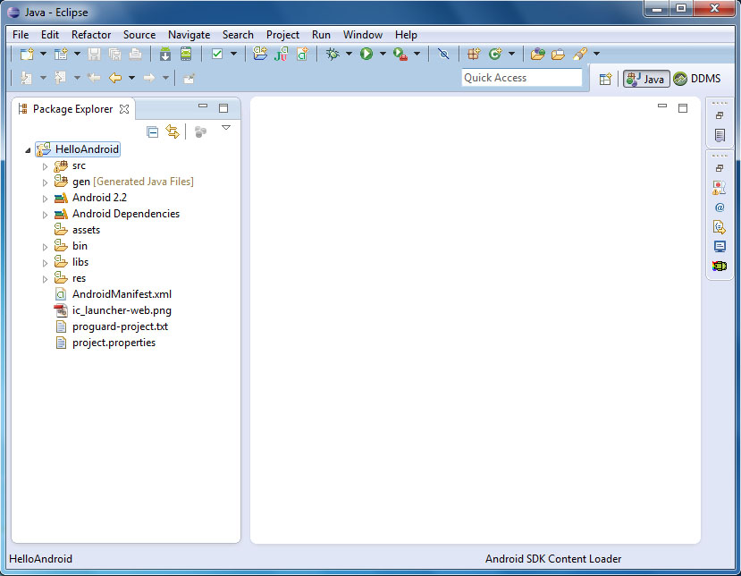
- For ADT Plugin Revision 16 or below, from the “Java Build Path” menu, select the “Libraries” tab. Then press “Add JARs…” button to add a .jar file required to use the SDK, IDTuniMagSDKAndroid.jar.
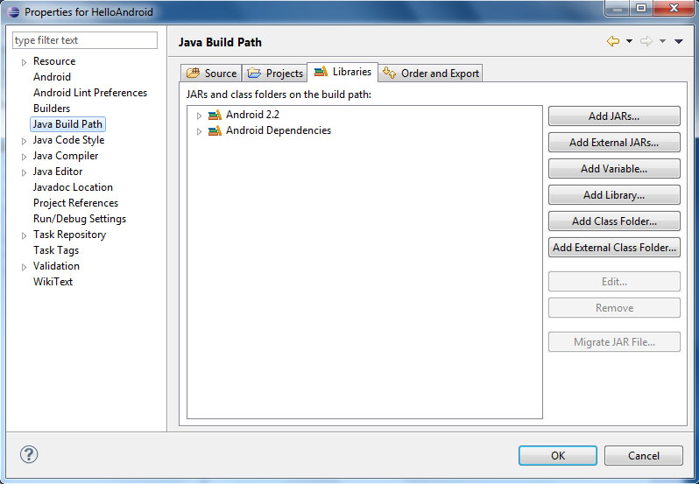
* Please note that adding library files using above method might cause “ClassNotFoundException” if you’re using ADT Plugin Revision 17 and above.
See below link for more information:
http://tools.android.com/recent/dealingwithdependenciesinandroidprojects
- For ADT Plugin Revision 17 and above, copy IDTuniMagSDKAndroid.jar file into “libs” folder. This will import the library automatically. 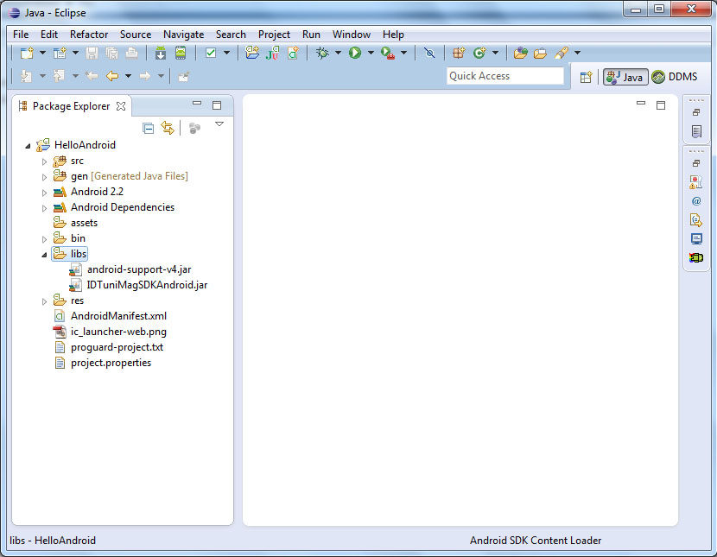
- On the Package Explorer panel, double click on the AndroidManifest.xml. Add the following permissions

<uses-permission android:name="android.permission.MODIFY_AUDIO_SETTINGS"/>
<uses-permission android:name="android.permission.RECORD_AUDIO"/>
<uses-permission android:name="android.permission.MOUNT_UNMOUNT_FILESYSTEMS"/>
<uses-permission android:name="android.permission.WRITE_EXTERNAL_STORAGE"/>
<uses-permission android:name="android.permission.INTERNET"/>

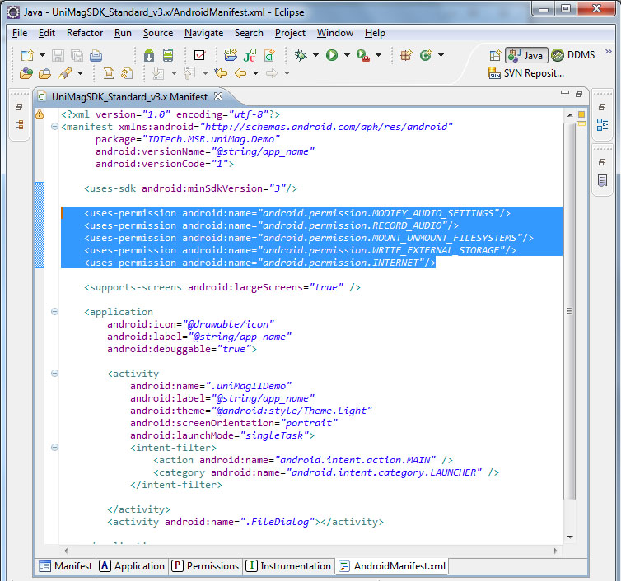
- Implement the interface uniMagReaderMsg in your Activity extension class.

There are some interface functions to implement, please see the following definition of each interface.
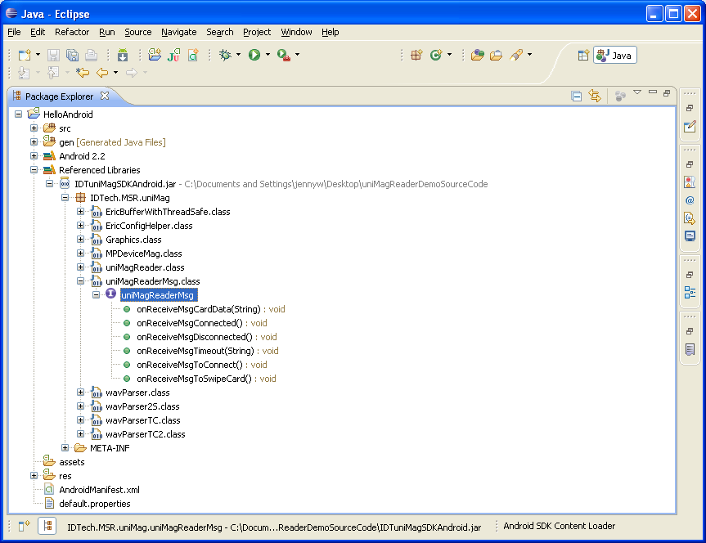

public interface uniMagReaderMsg {
//user grant type
public static final int typeToPowerupUniMag = 0;
public static final int typeToUpdateXML = 1;
public static final int typeToOverwriteXML = 2;
public static final int typeToTryAutoConfig = 3;
public static final int typeToReportToIdtech = 4;

//COMMAND ID LIST
public static final int cmdUnknown = 0;
public static final int cmdEnableTDES = 1;
public static final int cmdEnableAES = 2;
public static final int cmdGetVersion = 3;
public static final int cmdGetSettings = 4;
public static final int cmdSwipeCard = 5;

//new added commands 2012.03.08
public static final int cmdDefaultGeneralSetting = 6;
public static final int cmdGetSerialNumber = 7;
public static final int cmdGetNextKSN = 8;
public static final int cmdEnableErrorNotification = 9;
public static final int cmdDisableErrorNotification = 10;
public static final int cmdEnableExpDate = 11;
public static final int cmdDisableExpDate = 12;
public static final int cmdEnableForceEncryption = 13;
public static final int cmdDisableForceEncryption = 14;
public static final int cmdSetPrePAN = 15;
public static final int cmdClearBuffer = 16;

//callbacks SDK client must implement
public void onReceiveMsgToConnect();
public void onReceiveMsgConnected();
public void onReceiveMsgDisconnected();
public void onReceiveMsgTimeout(String strTimeoutMsg);
public void onReceiveMsgToSwipeCard();
public void onReceiveMsgCommandResult(int commandID, byte[] cmdReturn);
public void onReceiveMsgCardData(byte flagOfCardData , byte[] cardData);
public void onReceiveMsgProcessingCardData();
@Deprecated
public void onReceiveMsgSDCardDFailed(String strMSRData);
public void onReceiveMsgFailureInfo(int index , String strMessage);
public void onReceiveMsgAutoConfigProgress(int progressValue); (See description item #11)
public void onReceiveMsgAutoConfigProgress(int percent, double result, String profileName); (See description item #12)
public void onReceiveMsgAutoConfigCompleted(StructConfigParameters profile);
public boolean getUserGrant(int nType,String strMessage);
}
The following is the description for each interface
Item | Interface | Description
1 | onReceiveMsgToConnect | To receive massages when the device is powered up
2 | onReceiveMsgConnected | To receive massages when the UniMag device is connected to the phone
3 | onReceiveMsgDisconnected | To receive massages when the UniMag device is disconnected to the phone
4 | onReceiveMsgSDCardDFailed | To receive the Error message when the SD card is not valid.  This callback is deprecated and will never be invoked in SDK 2.6 and up.
5 | onReceiveMsgTimeout | To receive massages when power up or card swipe mode is timed out
6 | onReceiveMsgToSwipeCard | To receive massages when you swipe the card
7 | onReceiveMsgCardData | To receive the flag byte and the card data  The flag byte shows the card data format as follows.  If b0: 0, it is card data  If b0: 1, it is raw data  If b1: 0, the encryption is using TDES  If b1: 1, the encryption is using AES  If b2: 0, it is non-encrypted data  If b2: 1, it is encrypted data
8 | OnReceiveMsgProcessingCardData | To receive a message as soon as SDK detects a data coming from UniMag reader after startSwipeCard() API is called.
9 | onReceiveMsgFailureInfo | To receive the failure info and message when load the XML file.
10 | onReceiveMsgCommandResult | commandID:  the command ID,  cmdReturn:  received the byte data after send command.
11 | getUserGrant | To define permissions for SDK to do certain tasks:  The Grant type as follows.  - typeToPowerupUniMag:  Application has to set this value to true in order for SDK to start powering up UniMag when reader is plugged in the headphone jack.  - typeToUpdateXML  Application has to set this value to true in order for SDK to download the latest configuration file (.XML) from ID Tech web server if the mobile device has not been configured yet.  - typeToOverwriteXML  Application has to set this value to true in order for SDK to download the latest configuration file and overwrite existing file in the local storage  - typeToReportToIdtech  To report the issue to ID Tech when the mobile phone is not supported.
12 | onReceiveMsgAutoConfigProgress | To receive progress message reported by the running auto configuration session.
13 | onReceiveMsgAutoConfigProgress | To receive progress message and result value reported by the running auto configuration session.
14 | onReceiveMsgAutoConfigCompleted | To Receive message when AutoConfig found a new profile for the device, and to pass a new profile to the application in the form of object, StructConfigParameters.

- Manage the class uniMagReader to operate the UniMag Reader.
You can manage the class uniMagReader to start or stop swiping a card. First create an instance of uniMagReader and then invoke the function of the class. Following is class reference for uniMagReader.

SDK Life Cycle
These methods are for managing
uniMagReader(uniMagReaderMsg _callback, Context ctx)
uniMagReader constructor. _callback is the object to receive notification from the SDK. ctx is the application context (usually the Android Activity object).
uniMagReader(uniMagReaderMsg _callback, Context ctx, boolean enableConnectReaderWithCommand)
Additional constructor of uniMagReader. If enableConnectReaderWithCommand set to true, SDK will try to connect reader using Command.
(*UniMag and UniMag Pro readers are not compatible)
void setSDKToolProxy(uniMagReaderToolProxy _toolProxy)
Set the uniMagReaderToolProxy object which the SDK will use to perform reader firmware update.
void release()
Release SDK internal resources and stop SDK process. Should be invoked when reader is unplugged and when the application exits.

Headset event registration
void registerListen()
Registers SDK to receive headset attachment events. Should be invoked when app launchs.
void unregisterListen()
Unregisters SDK from receiving headset attachment events. Should be invoked when the app quits.

General information
String getSDKVersionInfo()
To get the SDK version string.
String getInfoManufacture()
To get the phone manufacturer string.
String getInfoModel()
To get the phone model string.

Logging
void WriteLogIntoFile(String strLogInfo)
To log events in the SDK log.
void setSaveLogEnable(boolean bSaveLog)
To set whether to save event log to SD card root directory. This method is ignored if a card swipe is in progress. See isSwipeCardRunning().
void setVerboseLoggingEnable(boolean verbose)
To set whether to cause logging to show in the Debug Log window.
void deleteLogs()
Delete logs saved by WriteLogIntoFile().

Configuration file loading
The SDK needs to look up information specific to each phone to operate reader. This information is maintained inside an XML configuration file.
void setXMLFileNameWithPath(String strXMLFilePathName)
To set the XML configuration filename with path. It can be null if you want default process. If it is null, the SDK will search the XML in the root path of SD Card and application path. It will download one and loading it from the web server when cannot find one in default path.
boolean loadingConfigurationXMLFile(boolean bUpdateAutomatically)
To loading the XML configuration from the file which is set by setXMLFileNameWithPath(). If error occured, SDK will also attempt to search the default path for configuration XML. If bUpdateAutomatically is true, SDK will attempt to download configuration from the web.
boolean downloadXMLFile(String strFileNameWithPath)
To request the SDK to download XML configuration from the web. Downloaded XML can then be loaded by calls to setXMLFileNameWithPath() and loadingConfigurationXMLFile().

Card swipe reading
boolean startSwipeCard()
To start a card swipe. Callback function uniMagReaderMsg.onReceiveMsgCardData() will be invoked when card data is received. If SDK does not detect card data from the reader within the interval specified by setTimeoutOfSwipeCard() uniMagReaderMsg.onReceiveMsgTimeout() will be invoked.
void stopSwipeCard()
To stop a card swipe. This function should be invoked when the app quits.
boolean isSwipeCardRunning()
To check to see if a card swipe is in progress.
boolean setTimeoutOfSwipeCard(int timeoutValue)
Set card swipe timeout. timeoutValue is in seconds.

Card reader commands
For all send card reader command APIs, return value is true when there's no error, is false otherwise. Result of the command will be returned via the callback uniMagReaderMsg.onReceiveMsgCommandResult(). If timeout error occurred, uniMagReaderMsg.onReceiveMsgTimeout() will be invoked. Format of data returned to onReceiveMsgCommandResult() is specified under response format for each send card reader command APIs. Format of data is specified as a hexadecimal string.
boolean sendCommandEnableTDES()
Send command to enable TDES
Response format:
Successful: 06
boolean sendCommandEnableAES()
Send command to enable AES
Successful: 06
boolean sendCommandGetVersion()
Send command to get reader firmware version as an ASCII string
Successful: 06 02 <reader firmware version> 03 <LRC>
boolean sendCommandGetSettings()
Send command to get reader settings binary dump
Successful: 06 02 <reader settings> 03 <LRC>
boolean sendCommandDefaultGeneralSettings()
Send command to set card reader general settings to default. Please note that since this command resets the reader's baud rate to a default value that may not match the value expected by the SDK, re-connecting the reader may be necessary. Also note that reconnecting a reader with unexpected baud rate may take longer than usual, at around 20 seconds.
Successful: 06
boolean sendCommandGetSerialNumber()
Send command to get card reader serial number
Successful: 06 02 <serial number> 03 <LRC>
boolean sendCommandGetNextKSN()
Send command to get encrypting reader Key Serial Number
Successful: 06 02 <10-byte KSN> 03 <LRC>
boolean sendCommandEnableErrNotification()
Send command to enable error notification from the reader
Successful: 06
boolean sendCommandDisnableErrNotification()
Send command to disable error notification from the reader
Successful: 06
boolean sendCommandEnableExpDate()
Send command to enable sending of card expiry day from the reader
Successful: 06
boolean sendCommandDisableExpDate()
Send command to disable sending of card expiry day from the reader
Successful: 06
boolean sendCommandEnableForceEncryption()
Send command to enable forced encryption of card data by the reader
Successful: 06
boolean sendCommandDisableForceEncryption()
Send command to disable forced encryption of card data by the reader
Successful: 06
boolean sendCommandSetPrePAN(int prePAN)
Send command to set how many card data digits are sent unmasked. Range of prePAN is 0~6. By default value is 4.
Successful: 06
Failed: 15
boolean sendCommandClearBuffer()
Send command to clear buffer.
Successful: 06 02 <06 or 15> 03 <LRC>

Automatic configuration computation
boolean startAutoConfig(boolean enableOverwriteResult)
Start the auto config process to attempt finding the configuration for a non-supported phone. Since auto config can be a lengthy process, the callback uniMagReaderMsg.onReceiveMsgAutoConfigProgress() is periodically called while auto config runs. And the progress message and result value also reported in the message onReceiveMsgAutoConfigProgress.
boolean startAutoConfig(String strXMLFilename, boolean enableOverwriteResult)
Start the auto config process to attempt finding the configuration from current XML config file for a non-supported phone. Since auto config can be a lengthy process, the callback uniMagReaderMsg.onReceiveMsgAutoConfigProgress() is periodically called while auto config runs. And the progress message and result value also reported in the message onReceiveMsgAutoConfigProgress.
void stopAutoConfig()
Abort the currently running auto config session.
boolean connectWithProfile (StructConfigParameters profile)
Upon receiving a new profile from the message, onReceiveMsgAutoConfigCompleted, connect uniMag reader with the profile.

Reader type and support status
ReaderType getAttachedReaderType()
Return the type of reader currently attached and powered up. Returns UNKNOWN if the reader type cannot be determined. As version 2.6 SDK is unable to differentiate between uniMag and uniMag Pro and will return UM_2G_OR_PRO when either type is attached. Returns null on error.
SupportStatus getSupportStatus(ReaderType readerType)
Return the support status as specified in the configuration file currently loaded by the SDK. Valid reader types are {UM, UM_PRO, UM_II, SHUTTLE}. Returns null on error.
enum ReaderType { UNKNOWN, UM_OR_PRO, UM, UM_PRO, UM_II, SHUTTLE }
The ReaderType type represents different variants of the uniMag family of card readers.

Type Definition
UNKNOWN Unknown type
UM_OR_PRO uniMag or uniMag Pro
UM uniMag
UM_PRO uniMag Pro
UM_II uniMag II
SHUTTLE Shuttle
enum SupportStatus { UNSUPPORTED, SUPPORTED, MAYBE_SUPPORTED }
The SupportStatus type represents phone-reader pair support, or compatibility, statues.

Type Definition
UNSUPPORTED Officially unsupported
SUPPORTED Officially supported
MAYBE_SUPPORTED Officially unsupported, but may be compatible

To update firmware using the UniMag Android SDK Tools
1. Implement the interface uniMagReaderToolsMsg in your Activity extension class. There are some interface functions to be implemented in order to use the firmware upgrade function. The interface name is ‘uniMagReaderToolsMsg’ which packed in the package ‘IDTech.MSR.uniMag.UniMagTools’, please see the following definition of each interface.

public interface uniMagReaderToolsMsg {
//get challenge return code
public static final int cmdGetChallenge_Succeed_WithChallengData = 201;
public static final int cmdGetChallenge_Failed = 202;
public static final int cmdGetChallenge_NeedSetBinFile = 203;
public static final int cmdGetChallenge_Timeout = 204;
public static final int cmdGetChallenge_Succeed_WithFileVersion = 205;
//update firmware return code
public static final int cmdUpdateFirmware_Succeed = 301;
public static final int cmdUpdateFirmware_EnterBootloadModeFailed = 302;
public static final int cmdUpdateFirmware_DownloadBlockFailed = 303;
public static final int cmdUpdateFirmware_EndDownloadBlockFailed = 304;
public static final int cmdUpdateFirmware_Timeout = 305;
public static final int cmdUpdateFirmware_NeedSetBinFile = 306;
public static final int cmdUpdateFirmware_NeedGetChallenge = 307;
public static final int cmdUpdateFirmware_Need8BytesData = 308;
public static final int cmdUpdateFirmware_Need24BytesData = 309;
//Interface Function
public void onReceiveMsgUpdateFirmwareProgress(int nProgressValue);
public void onReceiveMsgUpdateFirmwareResult(int result);
public void onReceiveMsgChallengeResult(int returnCode, byte []data);
}

The following is the description for each interface
Item | Interface | Description
1 | onReceiveMsgUpdateFirmwareProgress | To receive massage of update progress info when update firmware.  The parameter ‘progressValue’ value will be from 1 to 100 which indicates 1% to 100%.
2 | onReceiveMsgChallengeResult | To receive massage info when get the challenge data.  The parameter ‘returnCode’ value description as follows.  - 201, Get challenge succeed,  - 202, Get challenge failed, cannot get the data  - 203, Get challenge failed, need to set BIN file first  - 204, Get challenge timeout.  - 205, Get challenge succeed, already in the boot load mode, the data is the version info.  The parameter ‘data’ is the data array received.
3 | onReceiveMsgUpdateFirmwareResult | To receive massage info from the UniMag Unit when update the firmware.  The parameter ‘result’ value description as follows.  - 301, Update firmware succeed  - 302, Update firmware failed, cannot enter boot load mode  - 303, Update firmware failed, cannot download block data  - 304, Update firmware failed, cannot end download block  - 305, Update firmware timeout  - 306, Update firmware failed, need to set BIN file first  - 307, Update firmware failed, need to get challenge first  - 308, Update firmware failed, need input 8 bytes data  - 309, Update firmware failed, need input 24 bytes data

2. Manage the class uniMagSDKTools to operate the UniMag Reader.

You can use the class uniMagSDKTools to get challenge data and update firmware. First create an instance of uniMagSDKTools and then invoke the function of the class. The class functions are listed below:

package IDTech.MSR.uniMag.UniMagTools;
public class uniMagSDKTools {
public boolean setFirmwareBINFile(String strFilePathName);
public boolean setFirmwareEncryptedBINFile(String strFilePathName);
public void getChallenge();
public void updateFirmware(byte[]data);
public void setUniMagReader(uniMagReader instance);
public uniMagReaderToolProxy getSDKToolProxy();
}

The following is the description for each interface function.

Index | Function | Description
1 | setFirmwareBINFile(String strFilePathName) | To set firmware BIN file path and name to the tool.
2 | setFirmwareEncryptedBINFile(String strFilePathName) | To set firmware encrypted BIN file path and name to the tool.
3 | getChallenge() | To get the challenge data, and the result will be returned in the interface ‘onReceiveMsgChallengeResult’
4 | updateFirmware(byte[]data) | To update firmware with the encrypted data. The result will be returned in the interface ‘onReceiveMsgUpdateFirmwareResult’. The progress info will be in the interface ‘onReceiveMsgUpdateFirmwareProgress’.
5 | setUniMagReader(uniMagReader instance) | To set UniMag Reader instance, for the tool uses some function of uniMagReader.
6 | uniMagReaderToolProxy getSDKToolProxy() | To get the tool proxy interface, the proxy is used in the interface ‘myUniMagReader’.

Please refer to the following source code to support firmware update features. Before attempting card reader firmware update, ensure screen timeout interval of the Android device to longer than 15 minutes.
//Create the instance of uniMagReader
if(myUniMagReader==null) myUniMagReader = new uniMagReader(this,this);
myUniMagReader.registerListen();

//load the XML configuratin file
String fileNameWithPath = getXMLFileFromRaw();
if(!isFileExist(fileNameWithPath)) { fileNameWithPath = null; }
myUniMagReader.setXMLFileNameWithPath(fileNameWithPath);
myUniMagReader.loadingConfigurationXMLFile(true);

//Tool of update firmware
testUpdateFirmware = new uniMagSDKTools(this,this);
testUpdateFirmware.setUniMagReader(myUniMagReader);
myUniMagReader.setSDKToolProxy(testUpdateFirmware.getSDKToolProxy());
//set BIN file
fileNameWithPath = getBINFileFromRaw();
testUpdateFirmware.setFirmwareBINFile(fileNameWithPath);

//update firmware
testUpdateFirmware.getChallenge();
testUpdateFirmware.updateFirmware(dataChallenge_exTools);

For more information on how to use the above functions, please refer to the UniMag Android SDK demo source code.

3. A list of messages from SDK
Android SDK message list
Message API | Msg ID or Command | Message content
getUserGrant | typeToOverwriteXML | There is a new XML file available, do you want update it?
getUserGrant | typeToUpdateXML | Your XML file is the latest one, do you want reload it?
getUserGrant | typeToUpdateXML | Your phone model is not supported yet. Please click YES to update XML file or contact supporter.
getUserGrant | typeToUpdateXML | Failed to open XML file, do you want to update it?
getUserGrant | typeToReportToIdtech | This phone model is not supported by the current SDK. Please contact supporter for assistance.
getUserGrant | typeToPowerupUniMag | Device detected in headphone. Press Yes if it is UniMag.
onReceiveMsgFailureInfo | Error code: 0 | The XML file is not compatible with SDK
onReceiveMsgFailureInfo | Error code: 1 | N/A
onReceiveMsgFailureInfo | Error code: 2 | This phone model is not supported by the current SDK. Please contact supporter for assistance.
onReceiveMsgFailureInfo | Error code: 3 | Wrong XML file name, please set the filename or enable the auto update.
onReceiveMsgFailureInfo | Error code: 4 | The XML file does not exist and the auto update disabled.
onReceiveMsgFailureInfo | Error code: 5 | Cannot initialize the XML file. Please make sure the network is accessible.
onReceiveMsgFailureInfo | Error code: 6 | Fail to read XML file. Please report to supporter.
onReceiveMsgFailureInfo | Error code: 7 | Can’t download the XML file. Please make sure the network is accessible.
onReceiveMsgFailureInfo | Error code: 8 | Failed to increase media volume
onReceiveMsgTimeout | Swipe card | Timeout error. Please swipe card again.
onReceiveMsgTimeout | Connect the reader | Timeout error. Can’t detect UniMag reader, please check the device connection
onReceiveMsgTimeout | Start Auto config failed | Auto Config failed and you can try again.
onReceiveMsgTimeout | Connect the reader with unsupported phone | Your phone is not supported and you can try Auto Config.

Note:
1． Please do not connect the mobile phone to PC as the USB Mass Storage device when you swipe a card.

2． When the “to power up” dialog shows up on the screen for more than 30 seconds with no timeout error, please verify that the headphone Media Volume is set to maximum and reattach the UniMag device.

